# DAILY ASSESSMENT

|  |  |  |  |
| --- | --- | --- | --- |
| Date: | 2/07/2020 | Name: | Chesmi B R |
| Course: | **IIRS** | USN: | 4AL16EC100 |
| Topic: | **Introduction to global positioning system** | Semester & Section: | 8TH SEM & A Section |
| Github Repository: | Chesmibr |  |  |

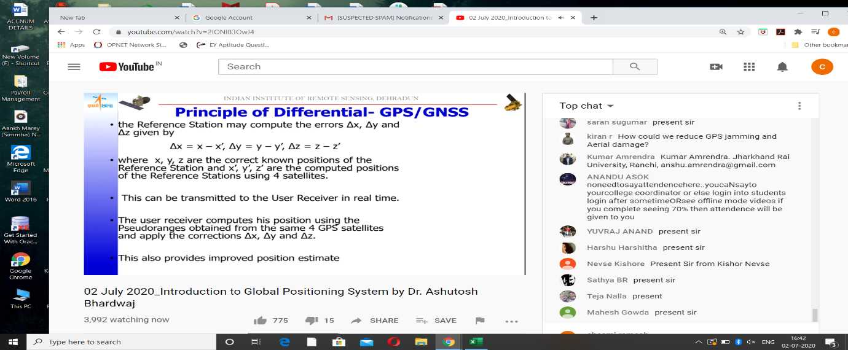

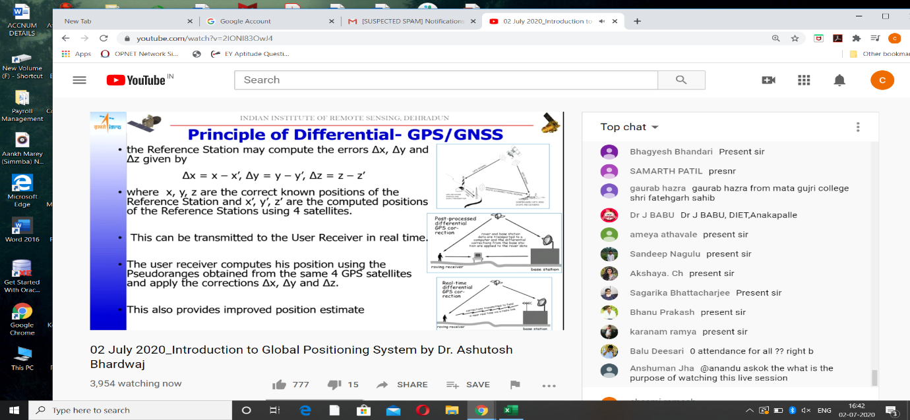

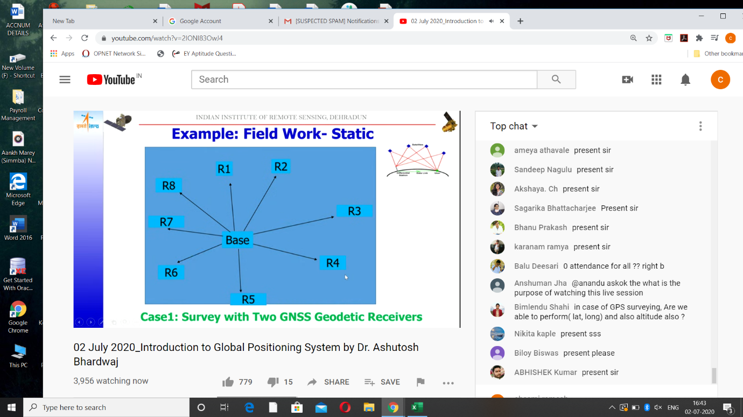

## What is GPS?

The Global Positioning System (GPS) is a U.S.-owned utility that provides users with positioning, navigation, and timing (PNT) services. This system consists of three segments: the space segment, the control segment, and the user segment. The U.S. Air Force develops, maintains, and operates the space and control segments.

The **Global Positioning System** (**GPS**), originally **NAVSTAR GPS**,[[1]](https://en.wikipedia.org/wiki/Global_Positioning_System#cite_note-1) is a satellite-based [radionavigation](https://en.wikipedia.org/wiki/Radionavigation-satellite_service" \o "Radionavigation-satellite service) system owned by the [United States](https://en.wikipedia.org/wiki/United_States) government and operated by the [United States Space Force](https://en.wikipedia.org/wiki/United_States_Space_Force).[[2]](https://en.wikipedia.org/wiki/Global_Positioning_System#cite_note-2) It is one of the [global navigation satellite systems](https://en.wikipedia.org/wiki/Satellite_navigation) (GNSS) that provides [geolocation](https://en.wikipedia.org/wiki/Geolocation) and [time information](https://en.wikipedia.org/wiki/Time_transfer) to a [GPS receiver](https://en.wikipedia.org/wiki/GPS_receiver) anywhere on or near the Earth where there is an unobstructed line of sight to four or more GPS satellites.[[3]](https://en.wikipedia.org/wiki/Global_Positioning_System#cite_note-3) Obstacles such as mountains and buildings block the relatively weak [GPS signals](https://en.wikipedia.org/wiki/GPS_signals).

The GPS does not require the user to transmit any data, and it operates independently of any telephonic or internet reception, though these technologies can enhance the usefulness of the GPS positioning information. The GPS provides critical positioning capabilities to military, civil, and commercial users around the world. The United States government created the system, maintains it, and makes it freely accessible to anyone with a [GPS receiver](https://en.wikipedia.org/wiki/GPS_navigation_device).

The GPS project was started by the [U.S. Department of Defense](https://en.wikipedia.org/wiki/United_States_Department_of_Defense) in 1973, with the first prototype spacecraft launched in 1978 and the full constellation of 24 satellites operational in 1993. Originally limited to use by the United States military, civilian use was allowed from the 1980s following an executive order from President [Ronald Reagan](https://en.wikipedia.org/wiki/Ronald_Reagan).[[5]](https://en.wikipedia.org/wiki/Global_Positioning_System#cite_note-5) Advances in technology and new demands on the existing system have now led to efforts to modernize the GPS and implement the next generation of [GPS Block IIIA](https://en.wikipedia.org/wiki/GPS_Block_IIIA) satellites and Next Generation Operational Control System (OCX).[[6]](https://en.wikipedia.org/wiki/Global_Positioning_System#cite_note-losangelesmil-6) Announcements from Vice President [Al Gore](https://en.wikipedia.org/wiki/Al_Gore) and the [White House](https://en.wikipedia.org/wiki/Clinton_Administration) in 1998 initiated these changes. In 2000, the [U.S. Congress](https://en.wikipedia.org/wiki/United_States_Congress) authorized the modernization effort, [GPS III](https://en.wikipedia.org/wiki/GPS_Block_IIIA). During the 1990s, GPS quality was degraded by the United States government in a program called "Selective Availability"; this was discontinued in May 2000 by a law signed by President [Bill Clinton](https://en.wikipedia.org/wiki/Bill_Clinton).

The GPS service is provided by the United States government, which can selectively deny access to the system, as happened to the Indian military in 1999 during the [Kargil War](https://en.wikipedia.org/wiki/Kargil_War" \o "Kargil War), or degrade the service at any time.[[8]](https://en.wikipedia.org/wiki/Global_Positioning_System#cite_note-8) As a result, several countries have developed or are in the process of setting up other global or regional satellite navigation systems. The Russian Global Navigation Satellite System ([GLONASS](https://en.wikipedia.org/wiki/GLONASS)) was developed contemporaneously with GPS, but suffered from incomplete coverage of the globe until the mid-2000s.[[9]](https://en.wikipedia.org/wiki/Global_Positioning_System#cite_note-9) GLONASS can be added to GPS devices, making more satellites available and enabling positions to be fixed more quickly and accurately, to within two meters (6.6 ft). China's [BeiDou Navigation Satellite System](https://en.wikipedia.org/wiki/BeiDou_Navigation_Satellite_System" \o "BeiDou Navigation Satellite System) began global services in 2018, and finished its full deployment in 2020.[[11]](https://en.wikipedia.org/wiki/Global_Positioning_System#cite_note-11) There are also the European Union [Galileo positioning system](https://en.wikipedia.org/wiki/Galileo_(satellite_navigation)), and India's [NavIC](https://en.wikipedia.org/wiki/Indian_Regional_Navigation_Satellite_System" \o "Indian Regional Navigation Satellite System). Japan's [Quasi-Zenith Satellite System](https://en.wikipedia.org/wiki/Quasi-Zenith_Satellite_System) (QZSS) is a GNSS [satellite-based augmentation system](https://en.wikipedia.org/wiki/GNSS_augmentation#Satellite-based_augmentation_system) to enhance GNSS's accuracy in [Asia-Oceania](https://en.wikipedia.org/wiki/Asia-Pacific), with [satellite navigation](https://en.wikipedia.org/wiki/Satellite_navigation) independent of GPS scheduled for 2023.

When selective availability was lifted in 2000, GPS had about a five-meter (16 ft) accuracy. The latest stage of accuracy enhancement uses the L5 band and is now fully deployed. GPS receivers released in 2018 that use the L5 band can have much higher accuracy, pinpointing to within 30 centimeters or 11.8 inches.

### Timeline and modernization

* In 1972, the USAF Central Inertial Guidance Test Facility (Holloman AFB) conducted developmental flight tests of four prototype GPS receivers in a Y configuration over [White Sands Missile Range](https://en.wikipedia.org/wiki/White_Sands_Missile_Range), using ground-based pseudo-satellites.
* In 1978, the first experimental Block-I GPS satellite was launched.
* In 1983, after Soviet [interceptor aircraft](https://en.wikipedia.org/wiki/Interceptor_aircraft) shot down the civilian airliner [KAL 007](https://en.wikipedia.org/wiki/Korean_Air_Flight_007) that strayed into [prohibited airspace](https://en.wikipedia.org/wiki/Prohibited_airspace) because of navigational errors, killing all 269 people on board, U.S. President [Ronald Reagan](https://en.wikipedia.org/wiki/Ronald_Reagan) announced that GPS would be made available for civilian uses once it was completed, although it had been previously published [in Navigation magazine], and that the CA code (Coarse/Acquisition code) would be available to civilian users.
* By 1985, ten more experimental Block-I satellites had been launched to validate the concept.
* Beginning in 1988, command and control of these satellites was moved from Onizuka AFS, California to the 2nd Satellite Control Squadron (2SCS) located at Falcon Air Force Station in Colorado Springs, Colorado.
* On February 14, 1989, the first modern Block-II satellite was launched.
* The [Gulf War](https://en.wikipedia.org/wiki/Gulf_War) from 1990 to 1991 was the first conflict in which the military widely used GPS.
* In 1991, a project to create a miniature GPS receiver successfully ended, replacing the previous 16 kg (35 lb) military receivers with a 1.25 kg (2.8 lb) handheld receiver.
* In 1992, the 2nd Space Wing, which originally managed the system, was inactivated and replaced by the [50th Space Wing](https://en.wikipedia.org/wiki/50th_Space_Wing).
* By December 1993, GPS achieved initial operational capability (IOC), with a full constellation (24 satellites) available and providing the Standard Positioning Service (SPS).
* Full Operational Capability (FOC) was declared by [Air Force Space Command](https://en.wikipedia.org/wiki/Air_Force_Space_Command) (AFSPC) in April 1995, signifying full availability of the military's secure Precise Positioning Service (PPS).
* In 1996, recognizing the importance of GPS to civilian users as well as military users, U.S. President [Bill Clinton](https://en.wikipedia.org/wiki/Bill_Clinton) issued a policy directive[[56]](https://en.wikipedia.org/wiki/Global_Positioning_System#cite_note-56) declaring GPS a [dual-use](https://en.wikipedia.org/wiki/Dual-use) system and establishing an [Interagency GPS Executive Board](https://en.wikipedia.org/wiki/Interagency_GPS_Executive_Board) to manage it as a national asset.
* In 1998, United States Vice President [Al Gore](https://en.wikipedia.org/wiki/Al_Gore) announced plans to upgrade GPS with two new civilian signals for enhanced user accuracy and reliability, particularly with respect to aviation safety, and in 2000 the [United States Congress](https://en.wikipedia.org/wiki/United_States_Congress) authorized the effort, referring to it as [GPS III](https://en.wikipedia.org/wiki/GPS_III).
* On May 2, 2000 "Selective Availability" was discontinued as a result of the 1996 executive order, allowing civilian users to receive a non-degraded signal globally.
* In 2004, the United States government signed an agreement with the European Community establishing cooperation related to GPS and Europe's [Galileo system](https://en.wikipedia.org/wiki/Galileo_(satellite_navigation)).
* In 2004, United States President [George W. Bush](https://en.wikipedia.org/wiki/George_W._Bush) updated the national policy and replaced the executive board with the National Executive Committee for Space-Based Positioning, Navigation, and Timing.
* November 2004, [Qualcomm](https://en.wikipedia.org/wiki/Qualcomm) announced successful tests of [assisted GPS](https://en.wikipedia.org/wiki/Assisted_GPS) for [mobile phones](https://en.wikipedia.org/wiki/Mobile_phones).
* In 2005, the first modernized GPS satellite was launched and began transmitting a second civilian signal (L2C) for enhanced user performance.
* On September 14, 2007, the aging mainframe-based [Ground Segment](https://en.wikipedia.org/wiki/Ground_segment) Control System was transferred to the new Architecture Evolution Plan.
* On May 19, 2009, the United States [Government Accountability Office](https://en.wikipedia.org/wiki/Government_Accountability_Office) issued a report warning that some GPS satellites could fail as soon as 2010.
* On May 21, 2009, the [Air Force Space Command](https://en.wikipedia.org/wiki/Air_Force_Space_Command) allayed fears of GPS failure, saying "There's only a small risk we will not continue to exceed our performance standard."
* On January 11, 2010, an update of ground control systems caused a software incompatibility with 8,000 to 10,000 military receivers manufactured by a division of Trimble Navigation Limited of Sunnyvale, Calif.
* On February 25, 2010, the U.S. Air Force awarded the contract to develop the GPS Next Generation Operational Control System (OCX) to improve accuracy and availability of GPS navigation signals, and serve as a critical part of GPS modernization.

### Awards

Air Force Space Commander presents [Gladys West](https://en.wikipedia.org/wiki/Gladys_West) with an award as she is inducted into the Air Force Space and Missile Pioneers Hall of Fame for her GPS work on Dec. 6, 2018.

On February 10, 1993, the [National Aeronautic Association](https://en.wikipedia.org/wiki/National_Aeronautic_Association) selected the GPS Team as winners of the 1992 [Robert J. Collier Trophy](https://en.wikipedia.org/wiki/Collier_Trophy), the US's most prestigious aviation award. This team combines researchers from the [Naval Research Laboratory](https://en.wikipedia.org/wiki/Naval_Research_Laboratory), the USAF, the [Aerospace Corporation](https://en.wikipedia.org/wiki/Aerospace_Corporation), [Rockwell International](https://en.wikipedia.org/wiki/Rockwell_International) Corporation, and [IBM](https://en.wikipedia.org/wiki/IBM) Federal Systems Company. The citation honors them "for the most significant development for safe and efficient navigation and surveillance of air and spacecraft since the introduction of [radio](https://en.wikipedia.org/wiki/Radio) navigation 50 years ago."

Two GPS developers received the [National Academy of Engineering](https://en.wikipedia.org/wiki/United_States_National_Academy_of_Engineering) [Charles Stark Draper Prize](https://en.wikipedia.org/wiki/Charles_Stark_Draper_Prize) for 2003:

* [Ivan Getting](https://en.wikipedia.org/wiki/Ivan_Getting), emeritus president of [The Aerospace Corporation](https://en.wikipedia.org/wiki/The_Aerospace_Corporation) and an engineer at the [Massachusetts Institute of Technology](https://en.wikipedia.org/wiki/Massachusetts_Institute_of_Technology), established the basis for GPS, improving on the [World War II](https://en.wikipedia.org/wiki/World_War_II) land-based radio system called [LORAN](https://en.wikipedia.org/wiki/LORAN) (Long-range Radio Aid to Navigation).
* [Bradford Parkinson](https://en.wikipedia.org/wiki/Bradford_Parkinson), professor of [aeronautics](https://en.wikipedia.org/wiki/Aeronautics) and [astronautics](https://en.wikipedia.org/wiki/Astronautics) at [Stanford University](https://en.wikipedia.org/wiki/Stanford_University), conceived the present satellite-based system in the early 1960s and developed it in conjunction with the U.S. Air Force. Parkinson served twenty-one years in the Air Force, from 1957 to 1978, and retired with the rank of colonel.

GPS developer [Roger L. Easton](https://en.wikipedia.org/wiki/Roger_L._Easton) received the [National Medal of Technology](https://en.wikipedia.org/wiki/National_Medal_of_Technology) on February 13, 2006.

[Francis X. Kane](https://en.wikipedia.org/wiki/Francis_X._Kane) (Col. USAF, ret.) was inducted into the U.S. Air Force Space and Missile Pioneers Hall of Fame at Lackland A.F.B., San Antonio, Texas, March 2, 2010 for his role in space technology development and the engineering design concept of GPS conducted as part of Project 621B.

In 1998, GPS technology was inducted into the [Space Foundation](https://en.wikipedia.org/wiki/Space_Foundation) [Space Technology Hall of Fame](https://en.wikipedia.org/wiki/Space_Technology_Hall_of_Fame).

On October 4, 2011, the [International Astronautical Federation](https://en.wikipedia.org/wiki/International_Astronautical_Federation) (IAF) awarded the Global Positioning System (GPS) its 60th Anniversary Award, nominated by IAF member, the American Institute for Aeronautics and Astronautics (AIAA). The IAF Honors and Awards Committee recognized the uniqueness of the GPS program and the exemplary role it has played in building international collaboration for the benefit of humanity.

[Gladys West](https://en.wikipedia.org/wiki/Gladys_West) was inducted into the Air Force Space and Missile Pioneers Hall of Fame in 2018 for recognition of her computational work which led to breakthroughs for GPS technology.

On February 12, 2019, four founding members of the project were awarded the Queen Elizabeth Prize for Engineering with the chair of the awarding board stating "Engineering is the foundation of civilisation; there is no other foundation; it makes things happen. And that's exactly what today's Laureates have done - they've made things happen. They've re-written, in a major way, the infrastructure of our world."